How to Work With the Thesis Template

*Thesis Template Guidelines 160121.docx, letzte Änderung durch T. Nonnen*

This document provides information on how to format theses (but also scientific documents in general) according to good scientific practice. For theses, the templates in the directory Y:\AKGAbschlussarbeiten\Thesis Template shall be used, where *YYMMDD* is the date of the latest changes in the file.

# General Remarks

* The document is best suited for single-sided printing (page numbers on the upper right).
* The entire document uses styles (German Word: Formatvorlagen) to format headings, text body, captions, highlights in the text, etc. It is strongly recommended to keep using them instead of manually editing the text formatting. This makes editing the document easier and helps to maintain consistence.
  + Default font: Cambria, 12pt, 1.5 line spacing, justified (Blocksatz)
  + Graphs can also be set in Arial
* The document uses formatting aids like page breaks and section breaks (Seiten- und Abschnittswechsel). Take care not to delete them when editing the document. Display the formatting symbols using the  button.
* Hints and placeholders are marked in the text. Replace the placeholders with the text and remove the yellow background setting it to “no color” using the  button.
* The parts of the thesis should approximately comprise the number of pages given in Tab. 1.1.

Tab. 1.1: Guidance for the extensiveness of a thesis’ parts.

|  |  |  |  |  |
| --- | --- | --- | --- | --- |
|  | B.Sc. | practical course (M.Sc. studies) | M.Sc. | Ph.D. |
| Introduction and Objectives | 1-2 | 1-2 | 1-2 | 2- 3 |
| Literature Overview | 2-5 | 2-5 | 10-15 | 15-25 |
| Experimental Section | 2-5 | 2-7 | <10 | 10-15 |
| Results and Discussion | ~10 | ~10 | ~20-30 | 40-70 |
| Conclusions and Outlook | 1 | 1-2 | 2-3 | 2- 4 |
| List of References | 3-5 | 3-5 | 5-10 | 10-15 |
| Appendix |  |  | <20-30 | <20-30 |

* Do not use more than four levels of subsections (max. 1.1.1.1)
* In English, capitalize the headings of the (sub)sections: http://grammar.yourdictionary.com/capitalization/rules-for-capitalization-in-titles.html
* Provide bound forms of your thesis for the submission to the examination office
  + 2 copies for B.Sc. and M.Sc.
  + 3 copies for PhD
* For the Institute, no printed forms are necessary, e.g., for practical courses, but electronic versions (Word and pdf). Name the documents in the format “MSc_Lastname_YYMMDD.docx”.

# Figures, Tables, and Equations

* The label of the captions (figures) and headings (tables) is set in **bold** face.
* Copy/paste the predefined entities from the examples given below to create new figures/tables/equations. They are formatted to
  + apply the correct formats, also for caption labels and caption text,
  + avoid page breaks between caption and figure or table, respectively.
* Figures and tables shall be placed at the top or at the bottom of a page. They should be mentioned in the text body before.

## Figures

* The caption goes below the figure and contains a description of what the figure shows. Also give, e.g., experimental conditions, if applicable. The caption should not contain an interpretation of the figure.
* Figures are referred to in the format “Fig. 1” from the text (“Abb.” in German)
* Graphs must have a frame.
* Use either Cambria or Arial font.
* Use ticks at all four sides of the graph, pointing inside.
* Limit the number of curves per graph to keep it simple (usually not more than three or four).
* If the plotted data are single data points, provide a dotted or dashed line as a “guide to the eye”. The legend must then only contain the data point symbols but not the line.
* If there is a functional correlation between Y and X values,e.g., a fitted model, a solid line may be used and added to the legend, separately from the data point symbols.
* There are Origin Design Files (*.oth files) available
  + Y:\AKGAbschlussarbeiten\Thesis Template\Page_Thesis*_<Font>_YYMMDD*.oth
  + Copy them to
    - English Windows: C:\Users*<username>*\Documents\OriginLab\Origin8\User Files\Themes\Graph
    - German Windows: C:\Users*<username>*\Documents\OriginLab\Origin8\Anwenderdateien\Themes\Graph\
  + Then you can use them via the Origin Design Manager (press F7 to open it).

|  |
| --- |
| **C:\Users\malnaji.ADTECH\AppData\Local\Microsoft\Windows\Temporary Internet Files\Content.IE5\GD18V5PL\ideasBulb[1].gif** |
| Fig. 2.1: This is an empty container which can be used for a single figure. |

## Tables

* The caption goes above the table.
* Tables are referred to as “Tab. 1” from the text.
* Horizontal lines (1.5 pt thickness) at top and bottom
* Horizontal line (0.5 pt thickness) to separate table header from content
* If listing numbers with decimal point, arrange them so that these decimal points are below each other. Also consider how many significant digits are justified in view of (experimental and calculation) accuracy.

Tab. 2.1: This is a table caption.

|  |  |
| --- | --- |
| Time $t$/  h | Temperature $T$/  K |
| 0 | 5.7 |
| 0.5 | 12.3 |
| 1.0 | 50.7 |
| 1.5 | 103.5 |

## Equations

* Equations shall be set using the formula editor (Insert 🡪 equation) (Einfügen 🡪 Formel)
* Also refer to section 2.5 for details of setting variables and units

By using a table as a container, equation (2.1) can be nicely set into the surrounding text.

|  |  |  |
| --- | --- | --- |
|  |  | (.) |

Here the text goes on…

## Automatic Numbering

* The numbering (e.g. Fig. 1.2) is done automatically by Word. Copy-paste the example figures/tables/equations to create a new figure/table/equation, press “Ctrl + A” (to select the whole document) and then “F9” in order to update the numbers.
* In order to reference to a figure/table/equation, use “References 🡪 Cross-reference” (“Verweise 🡪 Querverweis”)

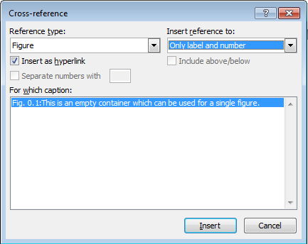

Unfortunately, when editing the same document on different machines, it can occur that the Reference Type you’d like to choose is not available. In this case see section 5.1.

* Select “Figure” or “Table” (“Abbildung”, “Tabelle”) in the upper left and “Only label and number” (“Nur Kategorie und Nummer”) in the upper right, select the reference from the field below and press “Insert” (“Einfügen”).
* For equations, do the same for the “Equation” (“Formel”), but select “complete text” (“Gesamte Beschriftung”) instead.
* The inserted reference may appear in bold text, because Word also copies the format of the caption label. Just select the inserted reference and apply the “Standard” style format to it.
* It is also possible to refer to sections: choose “numbered item” (“Nummeriertes Element”) or “heading” (“Überschrift”) from the dropdown menu.

## Variables, Units, Sub- and Superscripts

* Use SI units exclusively.
* Variables, units, sub- and superscripts are to be set according to DIN1338 (provided in the folder of this document and <https://de.wikipedia.org/wiki/Formelsatz> (German)). The most important rules are:
  + Numbers are always set upright: 10.5, ${10}^{6}$
  + Variables and functional assignments are set in italics: $E=m{\text{c}}^{2}$, $V=\frac{4}{3}\text{π}r^{3}$, $f\left(x\right)=x^{2}$
  + Sub- and superscripts are set upright, unless they are variables themselves: $m_{\text{salt}}$, $c_{p}$ (in this case the “p” is for pressure $p$)
  + Units (including prefixes) are set upright and separated from the scalar using a hard space (key stroke Ctrl + Shift + Spacebar): 273.15 K, $l=5.7 \text{µm}$,
  + Only the notation $\text{L mo}{\text{l}}^{\text{-1}}$ is to be used (not e.g. L/mol)
  + The hard space is also to be set before the percent symbol (DIN 5008): 50 %
  + Always give mol‑%, vol.‑%, wt.-%, or ma.‑% if applicable.
  + In the formula editor, first type the units, then use the option “normal text” to get upright characters
  + Commonly agreed constants, functions and operators are set upright: $f\left(x\right)=exp⁡(x)$, $\exp\left(\text{i} φ\right)=\cos\left(φ\right)+\text{i} sin⁡(φ)$, $\frac{\text{d}}{\text{d}x}f(x)$
  + Chemical symbols are set upright: Helium He, sulfuric acid H2SO4
  + Word abbreviations are set upright: Turnover Frequency $\text{TOF}=1 \text{mmol }{\text{L}}^{\text{-1}} {\text{s}}^{\text{-1}}$, Reynolds number $\text{Re}≥1000$, $\text{pH}=7$.

## References

* Use the reference manager Citavi to organize your literature and to manage your citations in the document.
* References have to be formatted using the latest Citavi style which can be found on the server in Y:\AKGLiteratur\Nützliches\Citavi\... …CitationsAKGläser_EN_*YYMMDD*.ccs (for thesis in English) …CitationsAKGläser_DE_*YYMMDD*.ccs (for thesis in German)

where *YYMMDD* is the date of the latest changes in the style file.

* Copy the style file to your “Custom Citation Styles” folder; the default directory is C:\Users*<username>*\Documents\Citavi 5\
* In Citavi, go to “Citation 🡪 Citation style 🡪 Browse citation styles” and choose the style.
* In the text, references are a part of a sentence [1]. Multiple references are formatted like [2,3] or [4–6].

## Special remarks

* Front page
  + The front page of the thesis will be in German, even if the thesis itself is written in English. The only exception is the title itself, which is English, if the thesis is written in English.
  + For thesis type and the grade to achieve fill in either (take care of the blanks in “M. Sc.” etc.)
    - BACHELORARBEIT / BACHELOR OF SCIENCE (B. Sc.)
    - MASTERARBEIT / MASTER OF SCIENCE (M. Sc.)
    - DISSERTATION / DOCTOR RERUM NATURALIUM (Dr. rer. nat)
  + Fill in your birthdate and birthplace (add the country if you were not born in Germany, e.g. “Paris, Frankreich”)
  + The last date is the date of the submission of the thesis

# References (Examples)

[1] K. Schumann, A. Brandt, B. Unger (2012) EP 2 527 296 A2.

[2] W. Schmidt, in: Inamuddin, M. Luqman (Eds.), Ion Exchange Technology I: Theory and Materials, Springer, Dordrecht, New York, 2012, pp. 277–298.

[3] M. Steiger, K. Linnow, H. Juling, G. Gulker, A. El Jarad, S. Bruggerhoff, D. Kirchner, Cryst. Growth Des. 8 (2008) 336–343.

[4] P. Atkins, J. de Paula, Physical Chemistry, 8th ed., Oxford University Press, Oxford, 2006.

[5] W. Wagner, D. Jähnig, C. Isaksson, R. Hausner, Modularer Energiespeicher nach dem Sorptionsprinzip mit hoher Energiedichte (MODESTORE). Abschlussbericht, 2006.

[6] K. Posern, Untersuchungen von Magnesiumsulfat-Hydraten und Sulfat/Chlorid-Mischungen für die Eignung als Aktivstoff in Kompositmaterialien für die thermochemische Wärmespeicherung. Dissertation, Bauhaus-Universität Weimar, Deutschland, 2012.

# Appendix A (Example Graphs)

|  |
| --- |
|  |
| Fig. 4.1: Line graph. Note that the legend only shows the symbols, but not the lines. The lines are fittet to the data points. They are displayed in dashed style since they serve only as a guide to the eye and do not suggest a relation of X and Y by a model. |

|  |
| --- |
|  |
| Fig. 4.2: XRD diffractograms of Samples A, B, and C. |

|  |
| --- |
|  |
| Fig. 4.3: Bar graph. |

# Appendix B (Troubleshooting)

## The Reference Type I would like to refer to doesn’t show up in the dropdown menu

This sometimes occurs because unfortunately Word does not update the automatically numbered fields in the document by itself. In this case proceed the following steps:

1. Find out what is the internal name for the reference type:
   1. Right-Click on one of the references in the document and choose “Edit Field…

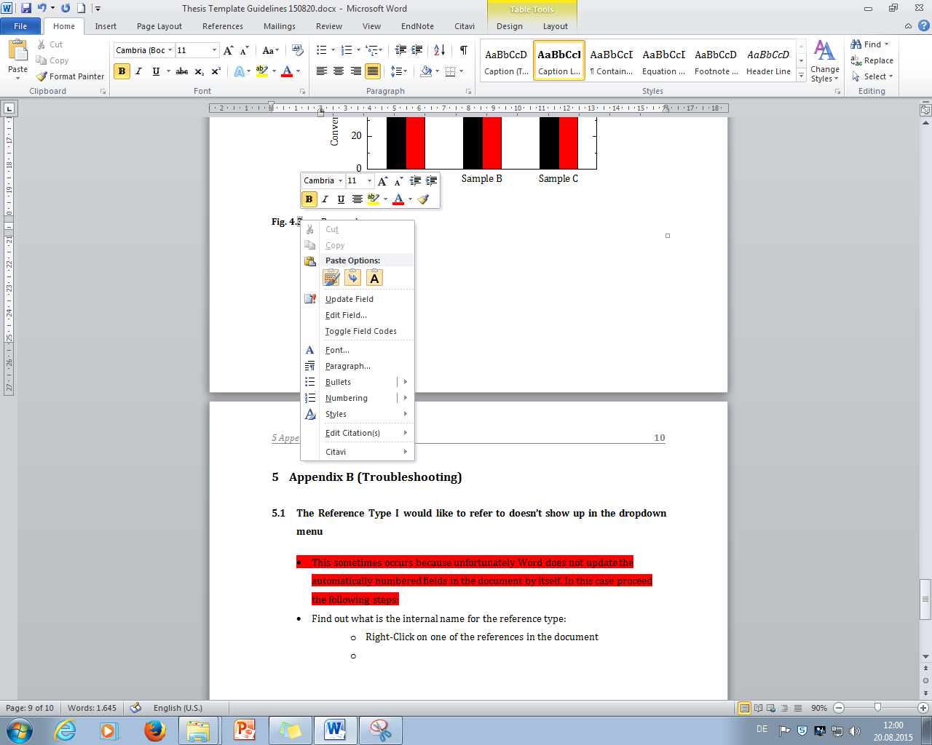

* 1. Then this dialog will show up:

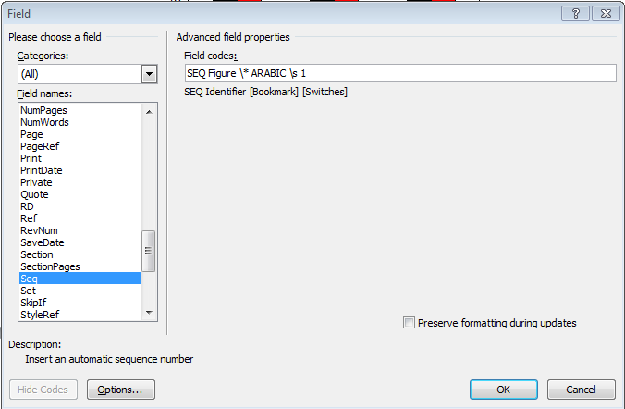

* 1. The name you are looking for in this case is “Figure”
  2. Close the dialog box and set the cursor in an empty line anywhere in the document. Select “References 🡪 Insert Caption” and then “New Label…” and type the name you determined above (“Figure” in this case).

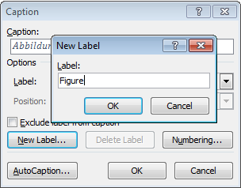

* 1. Confirm both dialog boxes with „OK“. Word will create a new caption in the empty line you previously selected. You can delete this and from now on should be able to select the reference type again as described in section 2.4.